FEDERAL BUDGET

HIGHER EDUCATION

NORTH – OSSETIAN STATE UNIVERSITY

**Faculty of Mathematics and Information Technology**

**Bachelor's direction**

**01/03/02 Applied Mathematics and Informatics**

**TRAINING PRACTICE:**

PRACTICE ON RECEIVING PRIMARY

PROFESSIONAL SKILLS AND SKILLS

**Fulfilled:**

**Anton Tskhovrebov, a 1st year student**

**Manager: Tsakhoyeva A.F.**

Head of the department: Associate Professor, Ph.D., Ph.D. Hudalov M.S

Vladikavkaz 2018

# Introduction

Numerical methods (computationalmethods, methods of computational) -a section of computational mathematicsand, studying approximate ways to solve typesx mathematicalproblems, which are either not solved, or difficult to solve by precise analytical methods (computational mattick in asense). mathematics relates to the range of issues related to computer use and programming. Dividing the methods of computation into analytical and numerical several conditional. It is necessary to emphasize the computer-oriented nature of numerical methods - in the end, their implementation is related to the use of computer technology and programming. Analytical solution of a problem in the form of separate formulaic ratios is an exception rather than a rule because of the complex and approximate nature of the models under study.

# Numerical integration

**The task of numerical integration is** to replace the original poniof thentereal function  *f (x)*for which it isdifficult or impossible to write down the original in analytics, some approximation function  *of q (x)*. .ный полином). То есть:

http://dssp.petrsu.ru/p/tutorial/meth_calc/files/04.files/image004.gifhttp://dssp.petrsu.ru/p/tutorial/meth_calc/files/04.files/image002.gif,

where there ishttp://dssp.petrsu.ru/p/tutorial/meth_calc/files/04.files/image006.gif *a prior error of the method* at the integration interval, and  *r(x)* is a prior error of the method on a separate step of integration.

## Rectangle method

There are methods of left, right and middle rectangles. The essence of the method is clear from Figure 1.At each step of integration, the function is approximated by a zero-degree polynom , a segment parallel to the axis of the abscissus. 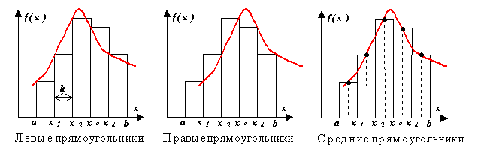Figure 1

Let's remove the rectangle method formula from *the f(x)* decomposition analysis to Taylor's row near a certain point x x *xi*.

http://dssp.petrsu.ru/p/tutorial/meth_calc/files/04.files/image012.gif...

Let's take a look at the integration range from xi to xi q h,where  *h* is the integration step..

Let's calculate ...http://dssp.petrsu.ru/p/tutorial/meth_calc/files/04.files/image014.gif

= = . We got a formulahttp://dssp.petrsu.ru/p/tutorial/meth_calc/files/04.files/image016.gifhttp://dssp.petrsu.ru/p/tutorial/meth_calc/files/04.files/image018.gif *of right (or left) rectangles* and a priori estimate of the error of *r* on a separate step of integration.

In the case of an equal *h* step across the entire integration range, the common formula has a look

http://dssp.petrsu.ru/p/tutorial/meth_calc/files/04.files/image020.gif.

Here *n* - the number of integration interval splits, . http://dssp.petrsu.ru/p/tutorial/meth_calc/files/04.files/image022.gif.

Here, at each interval, the function value is considered at the point, that is.http://dssp.petrsu.ru/p/tutorial/meth_calc/files/04.files/image024.gifhttp://dssp.petrsu.ru/p/tutorial/meth_calc/files/04.files/image026.gif

http://dssp.petrsu.ru/p/tutorial/meth_calc/files/04.files/image029.gif.

## The trapezia method

The approximation in this method is done by first-degree polyina. метода ясна из рисунка . At a single interval

http://dssp.petrsu.ru/p/tutorial/meth_calc/files/04.files/image031.gif.

In the case of a uniform mesh*(h* q const)

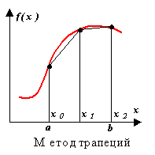

Figure 1

http://dssp.petrsu.ru/p/tutorial/meth_calc/files/04.files/image033.gif

At the same time, as well. The error of the trapezal method is twice as high as that of the medium rectanglemethod method! In practice, however, you can only find the average value at the elementary interval in the functions that are set analytically (rather than tabs), so it is not always possible to use the method of medium rectangles. Due to the different errors in the formulas of trapezes and medium rectangles, the true value of the integral usually lies between the two estimates.http://dssp.petrsu.ru/p/tutorial/meth_calc/files/04.files/image035.gifhttp://dssp.petrsu.ru/p/tutorial/meth_calc/files/04.files/image037.gif

## The Simpson Method

The integral function *f(x)* is replaced by second-degree  *P(x)* interpolation polyina, a parabola that passes through three nodes, for example, as shown in the picture ((1) - function, (2) - pauline).

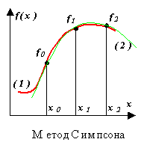

Figure 2

Consider the two steps of integration*(h* q const q  *xi* q 1 - *xi),*i.e. three nodes  *x0,x1,x2,*through which we will conduct parabola, using newton's equation:

http://dssp.petrsu.ru/p/tutorial/meth_calc/files/04.files/image053.gif.

Let z x - x0,then

http://dssp.petrsu.ru/p/tutorial/meth_calc/files/04.files/image055.gif

http://dssp.petrsu.ru/p/tutorial/meth_calc/files/04.files/image057.gif

Now, taking advantage of the resulting ratio, we calculate the integral at this interval:

http://dssp.petrsu.ru/p/tutorial/meth_calc/files/04.files/image059.gif

http://dssp.petrsu.ru/p/tutorial/meth_calc/files/04.files/image061.gif.

As a result,

http://dssp.petrsu.ru/p/tutorial/meth_calc/files/04.files/image063.gif

.   
For a uniform grid and an even number of steps n, Simpson's formula takes the form of:

http://dssp.petrsu.ru/p/tutorial/meth_calc/files/04.files/image065.gif

Here, andhttp://dssp.petrsu.ru/p/tutorial/meth_calc/files/04.files/image067.gifhttp://dssp.petrsu.ru/p/tutorial/meth_calc/files/04.files/image069.gif in the assumption of continuity of the fourth derivative of the integral function.

## Individual version number 22

$$\int_{0,6}^{1,4}{\frac{\sqrt{x^{2}+0,5} dx}{2x+ \sqrt{ x^{2}+2,5 }}}$$

$$\int_{0,2}^{0,8}{\frac{cos({x^{2}+1})dx}{2+\sin{(2x+0,5)}}}$$

## The text of the program

Using System

using System.Collections.Generic;

Using System.Linq

Using System.Text

Using System.Threading.Tasks;

namespace ConsoleApplication6

{

Class Program

{

static double Y (double x)

{

return x x;

1. Math.Sqrt (x x x q 0.5) / (2 x q Math.Sqrt (x x q x q 2.5))

2.Math.Cos (x x x q 1) / (2 q Math.Sin (2 x x q 0.5))

}

static void LT (double a, double b, double h)

q /Left

Double sum q 0;

for (double i q a; i qlt; b - h / 2; i q h)

{

sum q y (i) q h;

}

Console.WriteLineМЛТ

}

static void RT (double a, double b, double h)

q /right-wing

Double sum q 0;

for (double i q a; i qlt; b - h / 2; i q h)

{

sum q y (i q h) q h;

}

Console.WriteLineМПТ

}

static void CT (double a, double b, double h)

Q /Central

Double sum q 0;

for (double i q a; i qlt; b - h / 2; i q h)

{

sum q y (i q h /2) q h;

}

Console.WriteLineМСТ

}

static void MS (double a, double b, double h)

{

double x, s;

s q 0; x q a q h;

while (x qlt; b)

{

s q s q y y y(x);

x x x q h;

s q s q 2 q Y(x);

x x x q h;

}

s q h /3 (s q Y (a) - Y (b));

Console.WriteLine(MS {0}, s);

}

static void MT (double a, double b, double h)

/Trapeze

Double sum q 0;

Int count q 0;

for (double i q a; i qlt; b - h / 2; i q h)

{

sum (Y (i) q Y (i q h)) q h / 2;

}

Console.WriteLineТ

}

static void Main (string)

{

Double a q 0;

Double b q 1;

int n q 10;

double h (b - a) / n;

MS (a, b, h);

MT (a, b, h);

LT (a, b, h);

RT (a, b, h);

CT (a, b, h);

}

}

}

## Program results

|  |  |
| --- | --- |
| $$\int_{0}^{1}{x^{2}dx}$$ | MS 0.33333333333333333333333  MT 0.335  MLT 0.285  MPT 0.385  MST 0.3325 |

|  |  |
| --- | --- |
|  | MS 0.253992825786528  MT 0.25401714462711  MLT 0.25407484479835  MPT 0.25395944445587  MST 0.253980379364562 |

|  |  |
| --- | --- |
|  | MS 0.0579108939062036  MT 0.0578027442160447  MLT 0.0639835434068187  MPT 0.0516219450252707  MST 0.0579650760195568 |

# Numerical methods for solving non-linear equations

## Half-division method(the omy dicho method)

**The half-division method** is also known as the **dichotomy method.**. В данном методе интервал делится ровно пополам.

This approach ensures a guaranteed convergence of the method regardless of the complexity of the function - and this is a very important feature. The disadvantage of the method is the same - the method will never come together faster, i.e. the convergence of the method is always equal to convergence in the worst case.

Half-dividing method:

One of the easiest ways to find the roots of a single argument function..

2. Used to find the values of a valid-valued functiondefined by acriterion (this may be a comparison of a minimum, maximum or a specific number).

**Half-division method as function root search method**

**Statement of the method**

Before using the method to find the roots of the function, you need to separate the roots in one of the known ways, for example, by graphic method. Separating the roots is necessary if it is not known at what point you need to look for the root.

Let's assume that the root of the function is separated on the segment. The challenge is to find and refine this root by the method of half-division. In other words, you want to find a near-value of the root with a set accuracy.tf(x)=0[a,b]\eps

Let the function be continuous on the cut, and f[a,b]f(a)\cdot f(b)<0, \; \eps=0,01  
t\in[a,b]- the only root of the equation.f(x)=0, \; a\le t\le b

(We don't consider a case where the roots are several, t[a,b]o there is more than one. \eps можно взять и другое достаточно малое положительное число, например, .)0,001

Divide the cut in half. Let's get a point and two segments.[a,b]c= \frac {a+b}{2}, \; a<c<b[a,c], \; [c,b]

If, the root is found.f(c)=0tt=c

If not, then from the two segments received and it is necessary to choose one such that, that is,[a,c][c,b][a_1;b_1]f(a_1)\cdot f(b_1)<0

* + [a_1;b_1] = [a,c]If orf(a)\cdot f(c)<0
  + [a_1;b_1] = [c,b]If.f(c)\cdot f(b)<0

In order to find the approximate value of the root with precision, it is necessary to stop the process of half-division at such a step, on which you can calculate.[a_1;b_1]c_1=\frac {a_1+b_1}{2} \eps >0n|b_n-c_n|<\epsx=\frac {a_n+b_n}{2}t\approx x

**Algorithm**

Let the root of the equation

http://dit.isuct.ru/IVT/sitanov/Literatura/M501/Pages/Glava2_1.files/image015.gif

separated on *a*segment of*]a,*  *b,*i.e. *f((a))f(b)*  *qlt; 0* *(* and  *f'*  ***’****(x))* retains the sign (Figure 2.6). *(*

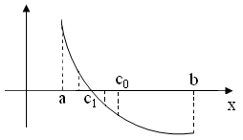

Fig. 2.6

As an initial approximation of the root, let's take point *from0* - the middle of the segment.

http://dit.isuct.ru/IVT/sitanov/Literatura/M501/Pages/Glava2_1.files/image016.gif.

If *f(from0)is 0,*then *c0* is the desired root of the equation, if

http://dit.isuct.ru/IVT/sitanov/Literatura/M501/Pages/Glava2_1.files/image017.gif,

*[c*that's from two segments of*]* *theaa,*  *c0,]* and *c 0,*  *b,* choose the one at the ends of which the function takes the value of the different characters.

The new segment is divided in half again and then we follow the above. The length of each new segment is half the length of the previous segment, i.e. *for n* steps will be reduced by *2n* times.

We stop the calculations if the length of *thec*segment is c*кto, witha q1,]*will be less than the specified error, i.e.:

http://dit.isuct.ru/IVT/sitanov/Literatura/M501/Pages/Glava2_1.files/image019.gif

Block-scheme algorithm to solve equations by Newton's method

Given on rice. 2.7

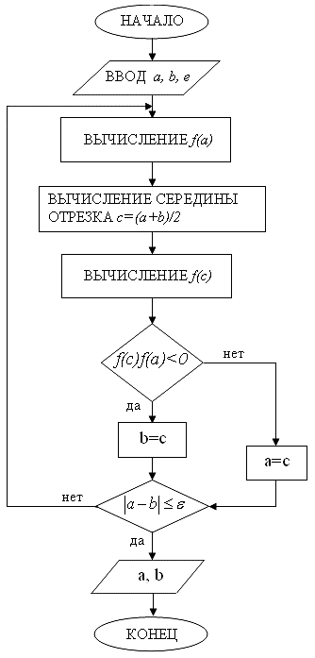

Figure 2.7 Half-Division Unit Block Scheme

## Individual version number 22

$2x+\cos{x}=0,5$*(Figure1))*

$$F\left(x\right)=2x+\cos{x}-0,5$$

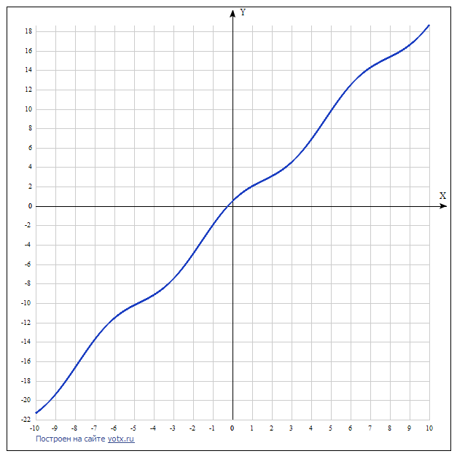

Figure 1

$x^{3}-0,2x^{2}+0,3x-1,2=0$*(Figure 2)*

$$F\left(x\right)=x^{3}-0.2x^{2}+0.3x-1.2$$

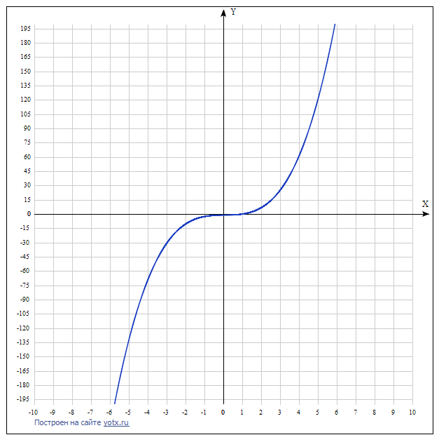

Figure 2

## The text of the program

Using System

using System.Collections.Generic;

Using System.Linq

Using System.Text

Using System.Threading.Tasks;

namespace ConsoleApplication9

{

Class Program

{

static double f (double x)

{

return 2/x math.Cos (x) - 0.5;

}

static void Main (string)

{

double a, b, c, epsilon 0.001;

a -1;

b q 0;

Int count q 0;

while (b - a zgt; epsilon)

{

c (a q b) / 2;

if (f (b) q f (c) qlt; 0)

A q c;

The other

b q c;

Count;

}

Console.WriteLine ("x" (a q b) / 2);

Console.WriteLine

}

}

}

## Program results

|  |  |
| --- | --- |
| $$2x+\cos{x}=0,5$$ | x -0.23583984375  n q 10 |

|  |  |
| --- | --- |
|  | x q 1,03369140625  n q 12 |

# The method of successive approximation (iteration method)

**The method of iteration** is [a numerical method](https://ru.wikipedia.org/wiki/%D0%92%D1%8B%D1%87%D0%B8%D1%81%D0%BB%D0%B8%D1%82%D0%B5%D0%BB%D1%8C%D0%BD%D1%8B%D0%B5_%D0%BC%D0%B5%D1%82%D0%BE%D0%B4%D1%8B) of solving mathematical problems, the approaching methofthe solution of [предела последовательности](https://ru.wikipedia.org/wiki/%D0%9F%D1%80%D0%B5%D0%B4%D0%B5%D0%BB_%D0%BF%D0%BE%D1%81%D0%BB%D0%B5%D0%B4%D0%BE%D0%B2%D0%B0%D1%82%D0%B5%D0%BB%D1%8C%D0%BD%D0%BE%D1%81%D1%82%D0%B8) the system of [linear algebraic](https://ru.wikipedia.org/wiki/%D0%A1%D0%B8%D1%81%D1%82%D0%B5%D0%BC%D0%B0_%D0%BB%D0%B8%D0%BD%D0%B5%D0%B9%D0%BD%D1%8B%D1%85_%D0%B0%D0%BB%D0%B3%D0%B5%D0%B1%D1%80%D0%B0%D0%B8%D1%87%D0%B5%D1%81%D0%BA%D0%B8%D1%85_%D1%83%D1%80%D0%B0%D0%B2%D0%BD%D0%B5%D0%BD%D0%B8%D0%B9)equations. convergence and the very fact of convergence of the method depends on the choice of the initial approximation of the root x0.

The simple iteration method is used to solve private-view equations where the equation can be written as a

F (x) x - f(x) q0.

Figure 3. 1 is given by thegeo-ethical interpretation of the method.

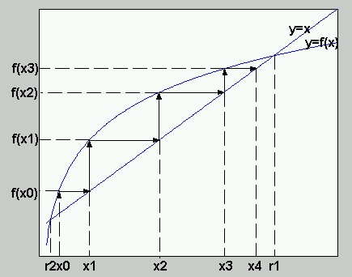

Figure 3.1 Geometric interpretation of simple iterations

The picture shows two graphs for the functions of U'x and y'f (x). The intersection points of these curves determine the roots of the x-f(x) equation. These roots are marked r1 and r2. The following procedure is proposed to find the root by simple iterations. Let's select the free x0 point on the x axis.

Continuing this process, you can see that each subsequent approach to the root is determinedthrough the previousformula

http://static.krasurao.ru/krasurao.ru/bvv/matlabcalc/lecture3/formula_iter.jpg

The following statement (without proof) is true. If the f (C0)is at the intersection of the charts of y'x and y'f (x), then the iterative process (3.1) converges to this point.

In our example, this point is the point of x'r1. Such roots are called attractive for the method of simple anderyats

The root of r2 in our example is repulsive and cannot be found by simple iterations (3.1). могут быть с его помощью найдены.

Algorithm block scheme to solve equations by simple

iterations are given to rice. 3.2.

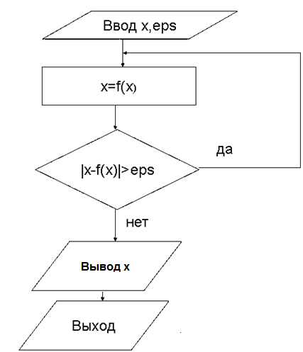

Figure 3.2

**Example**

$$2x+\lg\left(2x+3\right)=1$$

$$x= \frac{1}{2}-\frac{1}{2}lg⁡(2x+3)$$

$$φ\left(x\right)=\frac{1}{2}-\frac{1}{2}\lg\left(2x+3\right)= \frac{1}{2}-\frac{1}{2}\frac{ln⁡(2x+3)}{ln10}$$

$$φ^{/} \left(x\right)= -\frac{1}{2ln10}\frac{1}{2x+3}2=\frac{1}{ln10(2x+3)}$$

$$C_{0}= \frac{0.5+0}{2}=0.25$$

$${| φ}^{/} \left(0.25\right)|≈0.29$$

$0.29 <1$ The convergence condition is met

$C_{n+1}=\frac{1}{2}-\frac{1}{2}\lg\left(2C_{n}+3\right)$ The answeris: $x≈0.23-результат 2 иттераци$

## Individual version number 22

$2x+\cos{x}=0,5$ Graph (Figure 1)

$$2x=0.5-\cos{x}$$

$$x=\frac{0.5-\cos{x}}{2}$$

$$φ\left(x\right)=\frac{0.5-\cos{x}}{2}$$

$$C_{0}= \frac{-1+0}{2}=-0.5$$

$$φ^{/} \left(x\right)= \frac{\sin{x}}{2}$$

$${| φ}^{/} \left(-0.5\right)|≈0.239$$

$0.239 <1$ The convergence condition is met

**

Figure 1

$x^{3}-0,2x^{2}+0,3x-1,2=0$*(Figure 2)*

$$x^{3}=0.2x^{2}-0.3x+1.2$$

$$x= ∛(0.2x^{2}-0.3x+1.2)$$

$$φ\left(x\right)=∛(0.2x^{2}-0.3x+1.2)$$

$$C_{0}= \frac{-2+2}{2}=0$$

$$φ^{/} \left(x\right)= \frac{1}{3} {\left(0.2x^{2}-0.3x+1.2\right)}^{-\frac{2}{3}}(0.4x-0.3)$$

$${| φ}^{/} \left(0\right)|<1 – условие сходимости выполняется$$

*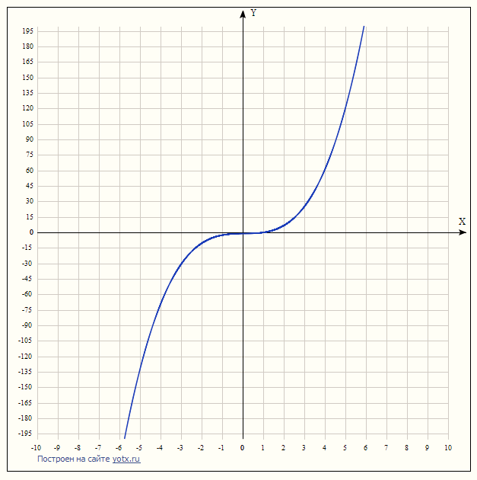*

Figure 2

## The text of the program

Using System

using System.Collections.Generic;

Using System.Linq

Using System.Text

Using System.Threading.Tasks;

namespace math

{

Class Program

{

static double f (double x)

{

return (0.5 - Math.Cos(x)/2;

}

static void Main (string)

{

double c -0.5;

double eps q 0.001;

Int count q 0;

Double x;

while (true)

{

Count;

x q f (c);

if (Math.Abs (x - c)

Break;

The other

c q x;

}

Console.WriteLine

Console.WriteLine

}

}

}

## Program results

|  |  |
| --- | --- |
| $$2x+\cos{x}=0,5$$ | x -0.236194691993718  n q 4 |

|  |  |
| --- | --- |
|  | x q 1,0313170464277  n q 9 |

# Newton Method (touch-tapmethod)

[астрономом Исааком Ньютоном](https://ru.wikipedia.org/wiki/%D0%90%D1%81%D1%82%D1%80%D0%BE%D0%BD%D0%BE%D0%BC) [1643](https://ru.wikipedia.org/wiki/1643)—[1727](https://ru.wikipedia.org/wiki/1727)Newton'sMethod, Newton's algorithm (also known as the [математиком](https://ru.wikipedia.org/wiki/%D0%9C%D0%B0%D1%82%D0%B5%D0%BC%D0%B0%D1%82%D0%B8%D0%BA) tangent method),is an iterative numerical method of finding [a](https://ru.wikipedia.org/wiki/%D0%A7%D0%B8%D1%81%D0%BB%D0%B5%D0%BD%D0%BD%D1%8B%D0%B5_%D0%BC%D0%B5%D1%82%D0%BE%D0%B4%D1%8B) root[(zero)](https://ru.wikipedia.org/wiki/%D0%9D%D1%83%D0%BB%D1%8C_%D1%84%D1%83%D0%BD%D0%BA%D1%86%D0%B8%D0%B8)of [a](https://ru.wikipedia.org/wiki/%D0%A4%D0%B8%D0%B7%D0%B8%D0%BA)given [function.](https://ru.wikipedia.org/wiki/%D0%A4%D1%83%D0%BD%D0%BA%D1%86%D0%B8%D1%8F_(%D0%BC%D0%B0%D1%82%D0%B5%D0%BC%D0%B0%D1%82%D0%B8%D0%BA%D0%B0)) the method [сходимостью](https://ru.wikipedia.org/wiki/%D0%A1%D0%BA%D0%BE%D1%80%D0%BE%D1%81%D1%82%D1%8C_%D1%81%D1%85%D0%BE%D0%B4%D0%B8%D0%BC%D0%BE%D1%81%D1%82%D0%B8)is based on successive approximations [and](https://ru.wikipedia.org/wiki/%D0%9C%D0%B5%D1%82%D0%BE%D0%B4_%D1%85%D0%BE%D1%80%D0%B4_%D0%B8_%D0%BA%D0%B0%D1%81%D0%B0%D1%82%D0%B5%D0%BB%D1%8C%D0%BD%D1%8B%D1%85) [задач оптимизации](https://ru.wikipedia.org/wiki/%D0%97%D0%B0%D0%B4%D0%B0%D1%87%D0%B0_%D0%BE%D0%BF%D1%82%D0%B8%D0%BC%D0%B8%D0%B7%D0%B0%D1%86%D0%B8%D0%B8) [производной](https://ru.wikipedia.org/wiki/%D0%9F%D1%80%D0%BE%D0%B8%D0%B7%D0%B2%D0%BE%D0%B4%D0%BD%D0%B0%D1%8F_%D1%84%D1%83%D0%BD%D0%BA%D1%86%D0%B8%D0%B8) [градиента](https://ru.wikipedia.org/wiki/%D0%93%D1%80%D0%B0%D0%B4%D0%B8%D0%B5%D0%BD%D1%82_(%D0%BC%D0%B0%D1%82%D0%B5%D0%BC%D0%B0%D1%82%D0%B8%D0%BA%D0%B0)) is based on the principles of [a simple](https://ru.wikipedia.org/wiki/%D0%9C%D0%B5%D1%82%D0%BE%D0%B4_%D0%BF%D1%80%D0%BE%D1%81%D1%82%D0%BE%D0%B9_%D0%B8%D1%82%D0%B5%D1%80%D0%B0%D1%86%D0%B8%D0%B8)iteration. multidimensional space.

**Justification**

To numerically solve the equation f(x)=0\![by simply](https://dic.academic.ru/dic.nsf/ruwiki/1034707)  [reiteration,](https://dic.academic.ru/dic.nsf/ruwiki/1034707)it is necessaryto lead to thefollowing form: x=\varphi(x)\!where \varphi\!- [compressing](https://dic.academic.ru/dic.nsf/ruwiki/682178)  [display.](https://dic.academic.ru/dic.nsf/ruwiki/682178). For the best convergence of the method at the point [of](https://dic.academic.ru/dic.nsf/ruwiki/430999) ищут x^*\! \varphi'(x^*)=0\! тогда: the next approximation must fulfill the \varphi(x)=x+\alpha(x) f(x)\!condition.

"varphi' (x)

Assuming that the approximation point is "close enough" to the root, \tilde{x}\!and that the given function is [continuous,](https://dic.academic.ru/dic.nsf/ruwiki/1111) (f(x^*)\approx f(\tilde{x})=0)\! the final formula for this \alpha(x)\!is:

"alpha(x) -----frac{1}'f'f's(x) !

With this in mind, the [function](https://dic.academic.ru/dic.nsf/ruwiki/7543) \varphi(x)\! is defined by the expression:

"varphi(x)

This function in the vicinity отображениеof the root iscompressive, and [the](https://dic.academic.ru/dic.nsf/ruwiki/1034689#cite_note-0)algorithm for finding a numerical solution to the equation f(x)=0\!boils down to an iterative calculation procedure:

x_'s x_n x_ x_n!

**Geometric interpretation**

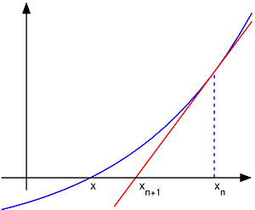

The illustration of Newton's method depicts a f(x)\!function that needs to be found, tangential at the point of the next approach Here we can x_n\!see, whatthe subsequent approximation is better than the previous x_{n+1}\!one. x_n\!.

The basic idea of the method is this: the initial approximation near the intended root is set, after which the tangent to the study function is built at the point of approximation, for which there is an intersection with the axis of the abscissus. This point is taken as the next approach. And so on, until the necessary accuracy is achieved.

Let it be defined onf(x):\;[a,\;b]\to\mathbb{R}\!*a*the segmenta, *b,*and the function that is [validated](https://dic.academic.ru/dic.nsf/ruwiki/13919) on it.

f'(x_{n}) = \operatorname{tg}\,\alpha = \frac{ \mathrm{\Delta y} }{ \mathrm{\Delta x} } = \frac{ f( x_{n} ) - 0 }{ x_{n} - x_{n+1} } = \frac{0 - f(x_{n})}{x_{n+1} - x_{n}}\,\!,

where the angle is the tangent at point.x_n\!

Hence the expression the desired expression for has the appearance of:x_{n+1}\!

x_{n+1} = x_n - \frac{f(x_n)}{f'(x_n)}\,\!.

The iteration process starts with some initial approximation *of x*0 (the closer to zero, the better, but if there are no assumptions about finding a solution, you can narrow down the scope of possible values by applying an [intermediate theorem).](https://dic.academic.ru/dic.nsf/ruwiki/1253994)  [значениях](https://dic.academic.ru/dic.nsf/ruwiki/1253994)).

**Algorithm**

Set by the initial approximation of *x*0..

So far, the stop condition, which can be met in theson-in-law or |x_{n+1}-x_n|&amp;lt;\varepsilon\! |f(x_{n+1})|&amp;lt;\varepsilon\!

(i.e. a marginof error inthepre-Elys), calculate a new approximation: пред

x_'x_n's frac'f (x_n x_n)

Block-scheme algorithm to solve equations by Newton's method

Given on Figure 4

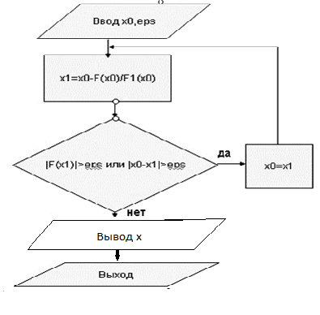

Figure 4

**Example**

$$1) 2x+\lg\left(2x+3\right)-1=0$$

$$F\left(x\right)=2x+\lg\left(2x+3\right)-1$$

$$F^{/}=2+\frac{2}{ln 10(2x+3)}$$

$$C_{n+1}= C_{n}-\frac{2C_{n}+\lg\left(2C_{n}+3\right)-1}{2}=2+\frac{2}{ln10(2C_{n}+3)}$$

$$C_{0}=0.25$$

$$x ≈0.2$$

$$2) x^{3}-2x^{2}+7x+3=0$$

$$F\left(x\right)=x^{3}-2x^{2}+7x+3$$

$$F^{/}=3x^{2}-4x+7$$

$$C_{n+1}= C_{n}-\frac{{C_{n}}^{3}-2{C_{n}}^{2}+7C_{n}+3}{3{C_{n}}^{2}-4C_{n}+7}$$

$$C_{0}=-0.5$$

$$x≈-0.38$$

## Individual version number 22

$$1) 2x+\cos{x}=0,5$$

$$F\left(x\right)=2x+\cos{x}-0,5$$

$$F^{/}\left(x\right)=2- \sin{x}$$

$$C_{0}= \frac{-1+0}{2}=-0.5$$

$$2) x^{3}-0.2x^{2}+0.3x-1.2=0$$

$$F\left(x\right)=x^{3}-0.2x^{2}+0.3x-1.2$$

$$F^{/}\left(x\right)=3x^{2}-0.4x+0.3$$

$$C_{0}= \frac{1+0}{2}=0.5$$

## The text of the program

Using System

using System.Collections.Generic;

Using System.Linq

Using System.Text

Using System.Threading.Tasks;

namespace math

{

Class Program

{

static double f (double x)

{

return 2 x q Math.Cos (x) - 0.5;

}

static double p (double x)

{

return 2 - Math.Sin(x);

}

static void Main (string)

{

double eps q 0.001;

double c -0.5;

Double x;

Int count q 0;

while (true)

{

Count;

x q c - f (c) / p (c);

if(Math.Abs (x-c)

Break;

The other

c'x;

}

Console.WriteLine

Console. WriteLine("n"n q count); count

}

}

}

## Program results

|  |  |
| --- | --- |
| $$2x+\cos{x}=0,5$$ | x -0.24896707789014  n q 1 |

|  |  |
| --- | --- |
|  | x q 1,03339326044463  n q 3 |

# Conclusion

In calculating integrals by numerical integration methods, Simpson's method proved to be the most accurate method of calculating integral.

In the course of solving the equation numerical methods, Newton's method proved to be the most effective.

|  |  |  |
| --- | --- | --- |
|  | $$2x+\cos{x}=0,5$$ | $$x^{3}-0,2x^{2}+0,3x-1,2=0$$ |
| Dichotomy Method | 10 | 12 |
| Iteration Method | 4 | 9 |
| Newton Method | 1 | 3 |

Itis clear from the blitz that Newton's method of response was calculated for a smaller amount of iteration than by iteration method and by dichotomy method.

# References

1. Solodovnikov, A.S. Numerical methods of linear algebra: Training manual / A.S. Solodovnikov. - M.: Finance and statistics, 2012. - 480 c.
2. Vabishchevic, P.N. Numerical Methods: Computational Workshop / P.N. Vabishchevic. - M.: Lenand, 2016. - 320 c.
3. Protasov I.D. Lectures on Computational Mathematics: Study. That's it. - M.: Helios ARV, 2009.
4. Yerokhin, B.T. Numerical Methods: Study Manual / B.T. Yerokhin. - St. Petersburg: Lan KPT, 2016. - 256 c.
5. Pirumov, W.G. Numerical methods: theory and practice: Teaching aid for bachelors / W.G. Pirumov, V.Y. Gidaspov, I.E. Ivanov. - M.: Yuright, 2012. - 421 c.
6. Shiryaev, V.I. Operations Research and numerical optimization methods: Training Manual / V.I. Shiryaev. - M.: Lenand, 2015. - 216 c.
7. Kireev, V.I. Numerical methods in examples and tasks: Study manual / V.I. Kireev, A.V. Panteleyev. - St. Petersburg: Lan, 2015. - 448 c.
8. Tsitan, N.N. Numerical Methods / N.N. Tittmann. - St. Petersburg: BHV, 2014. - 592 c.